Day18 Revisit

* Servlets
* HTML Concepts
* Client/Server Technology
* Types of Servers [Web/Application/Database]
* Creating Dynamic Web Application in Eclipse and adding Servlet to it.
* Deployment Descriptor (web.xml)

Day19

Deep Dive Servlet Technology.

Sample programs to do CURD operation using Servlet.

MVC Design Pattern

Today It’s full of Hands-on. No Theory.

1. Pls Open Eclipse
2. Create a Dynamic Web Project (File🡪 New🡪Dynamic Web Project)

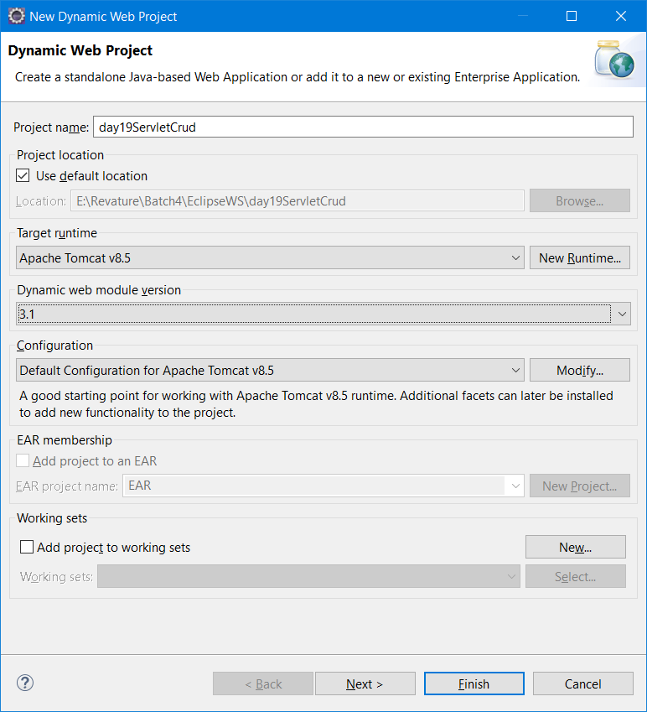

1. Web.xml (Also called as deployment descriptor) is the starting point for dynamic web project if it is available.
2. Right click the project 🡪 Select Project Facets 🡪 Select the Proper java version (1.8) click “apply & close” button.
3. Dynamic Web Project folder structure src/main/java, src/main/webapp (META-INF, WEB-INF [Deployment Assembly] it will contain web.xml & lib folder)
4. Add index.html
5. Add ViewEmployeeServlet
6. Add Driver Jar in buildpath & deployment assembly
7. Servlet is a Server Side Code (It gets executed in server - tomcat)

Client (Browser – Chrome/Firefox/Edge) – Server (Tomcat)

Request Object (client details) --🡪 Server will process the request & Create response Object.

DNS – Domain Naming System (176.87.211.75) – google.com

By default the landing page / home page is named as index.html/home.html/default.html

Tomcat can execute both Servlet & JSP (Server side codes)

Types of Servlet

1. Generic Servlet (Can be used for any protocol) – ftp, smtp, http, pop, imap, [public class FirstServlet extends GenericServlet]
2. HttpServlet (used with http protocol only) [public class MyServlet extends HttpServlet]

Protocol – Set of rules

http – hypertext transfer protocol which deals with rules associated with transferring hypertext between two or more devices.

For our understanding purpose, both client & server applications are residing in the same system.

Client (Browser) -- Server (Tomcat)

Public int add(int a, int b) {

Return (a+b);

}

Obj.add(5,6);

Servlet – HTML code is embedded inside java code.

JSP – Java Server Pages - Java code is embedded inside HTML

<!DOCTYPE html>

<html lang="en">

<head>

    <meta charset="UTF-8">

    <meta http-equiv="X-UA-Compatible" content="IE=edge">

    <meta name="viewport" content="width=device-width, initial-scale=1.0">

    <title>Document</title>

</head>

<body>

    <script>

        function calculate() {

            document.getElementById("result").innerText = parseInt(document.getElementById("input1").value) + parseInt(document.getElementById("input2").value);

        }

    </script>

    <form method="GET">

        <label>input1:</label>

        <input type="number" name="input1" id="input1" placeholder="Enter a number" />

        <label>input2:</label>

        <input type="number" name="input2" id="input2" placeholder="Enter a number" />

        <input type="reset" value="Clear" />

        <input type="button" value="CalcualteSum" onclick="calculate()" />

        <div id="result"> </div>

    </form>

</body>

</html>

